ASSIGNMENT:1

• Install Power BI Desktop and share the final screenshot of the report view page which appears when power desktop starts.

Power BI Desktop installation view

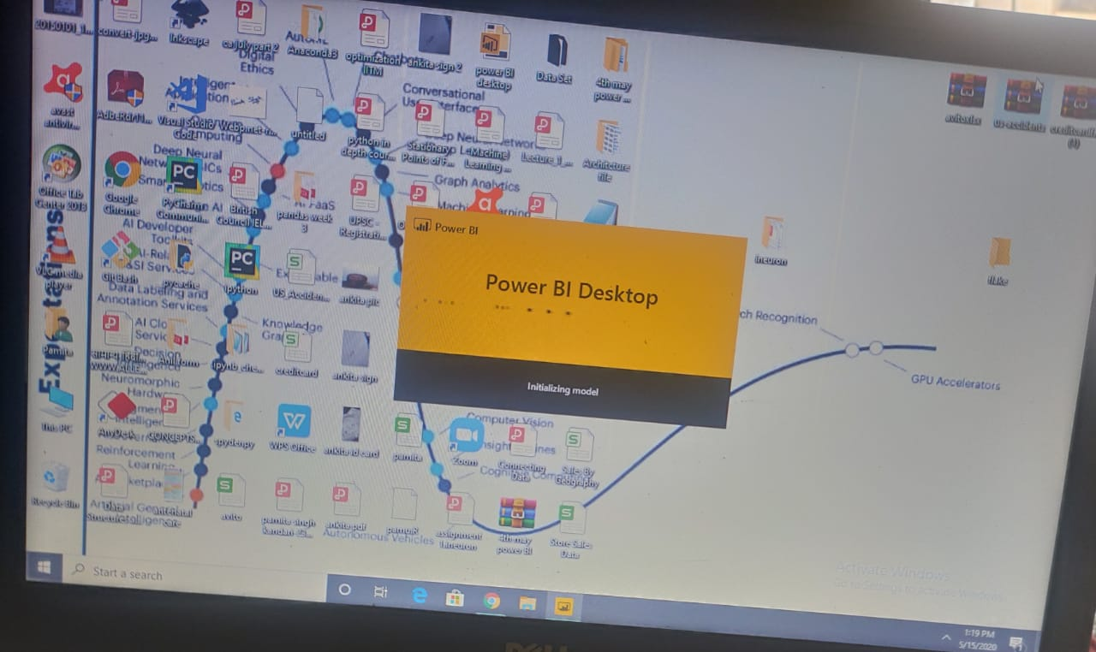

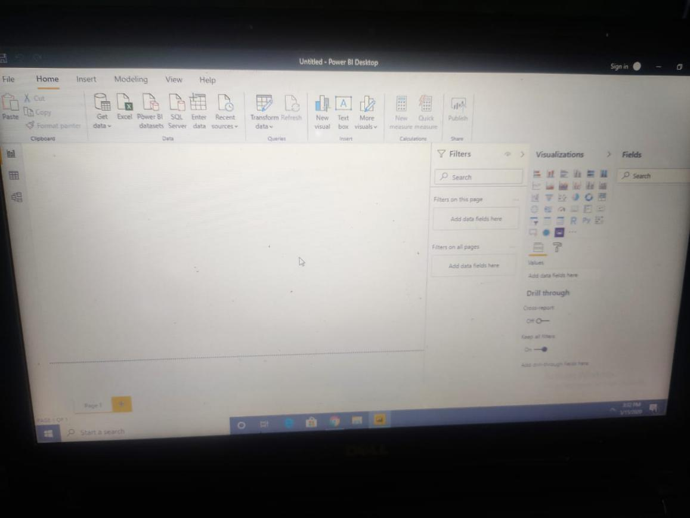
report view page

• Prepare a document with details of the following along with their price − Power BI Desktop − Power BI Pro − Power BI Premium

ANSWER 2 :

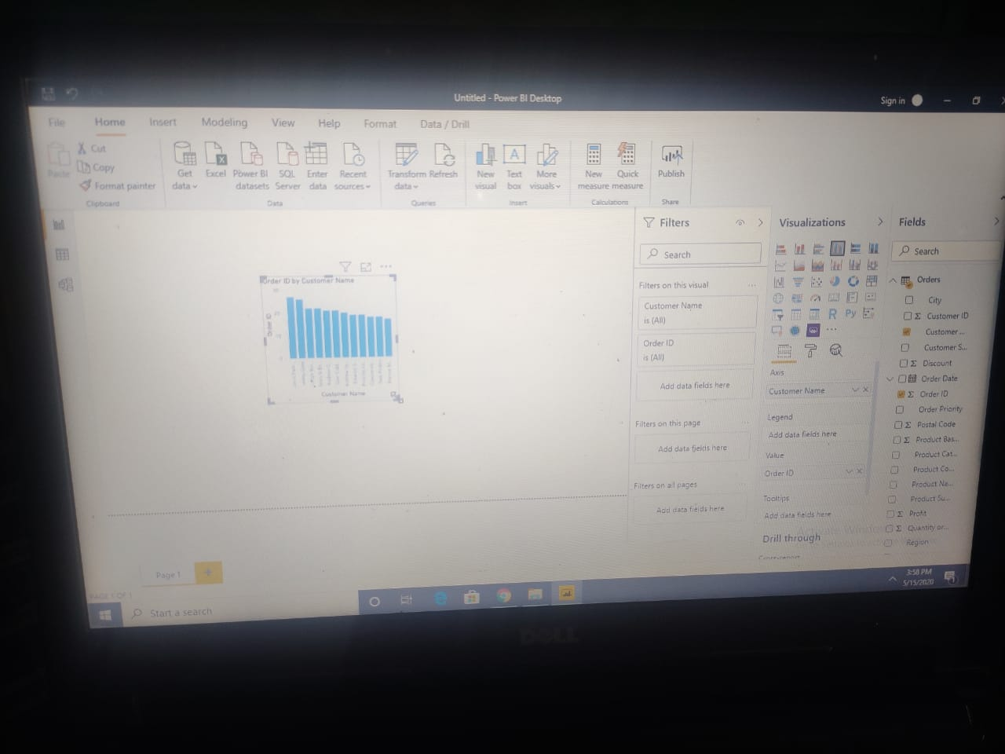

-Report view screenshot

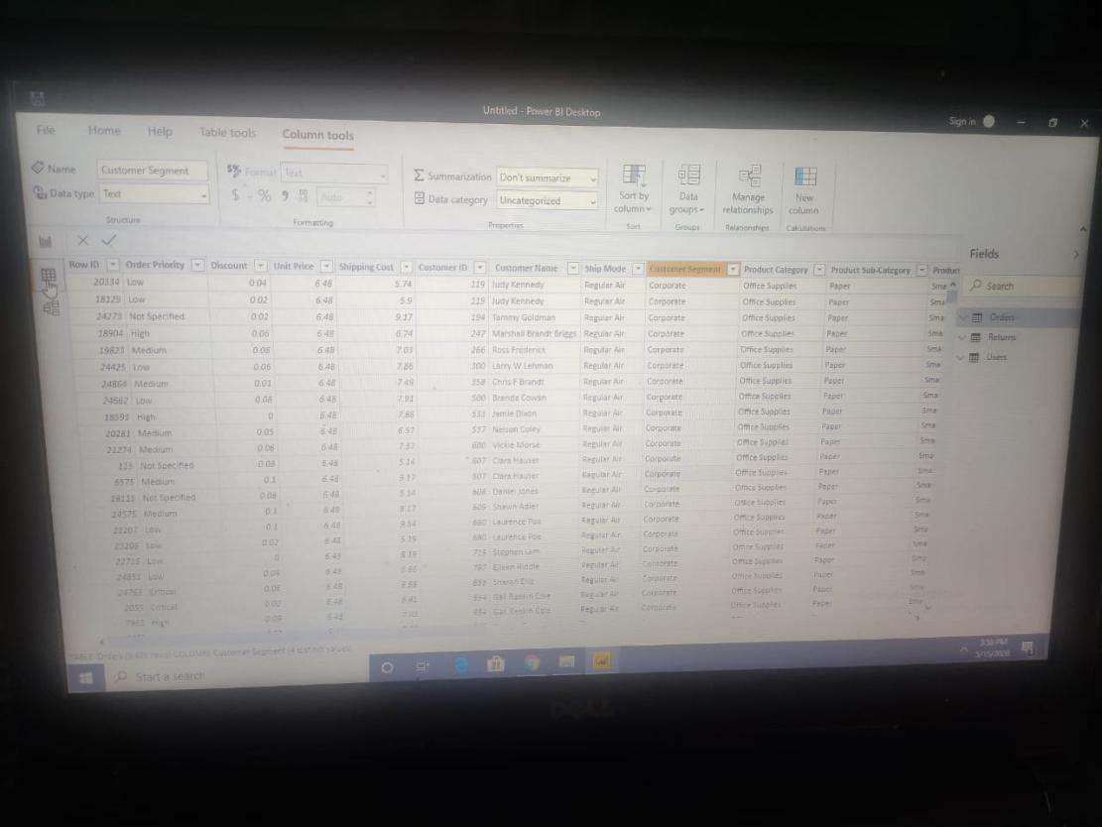
Data view screenshot

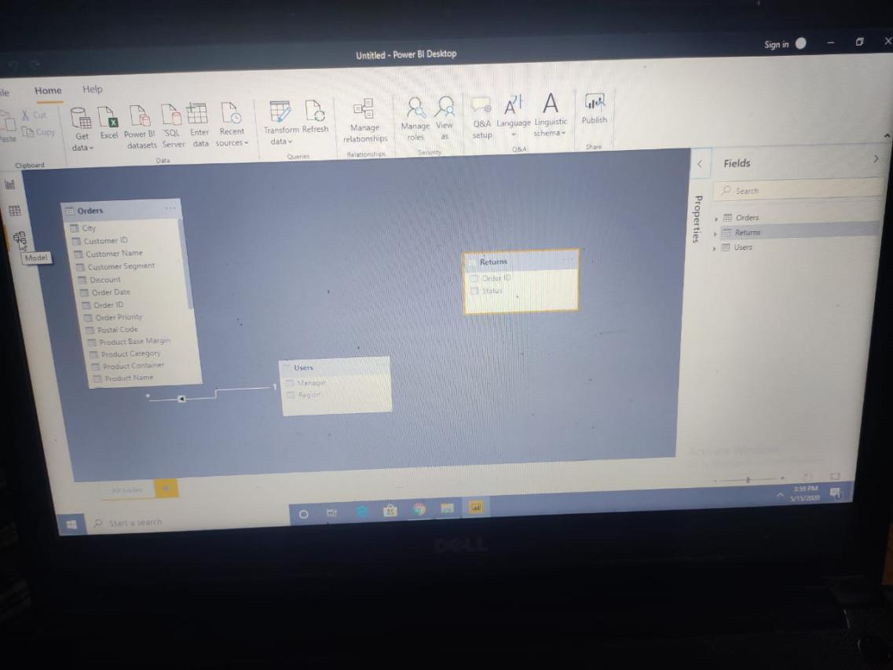

Model view screenshot

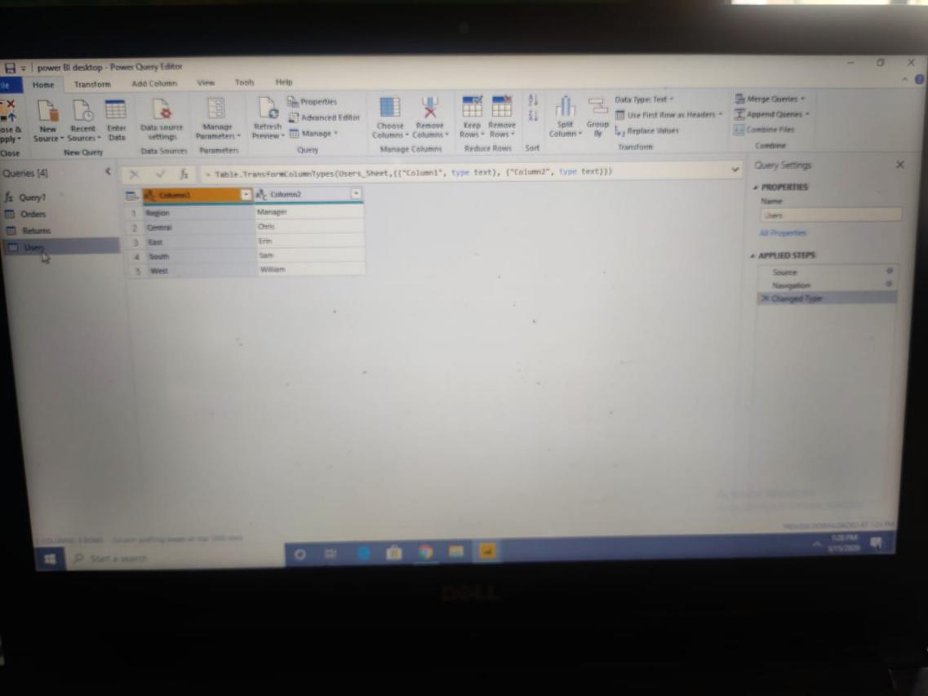

Query Editor Screenshot

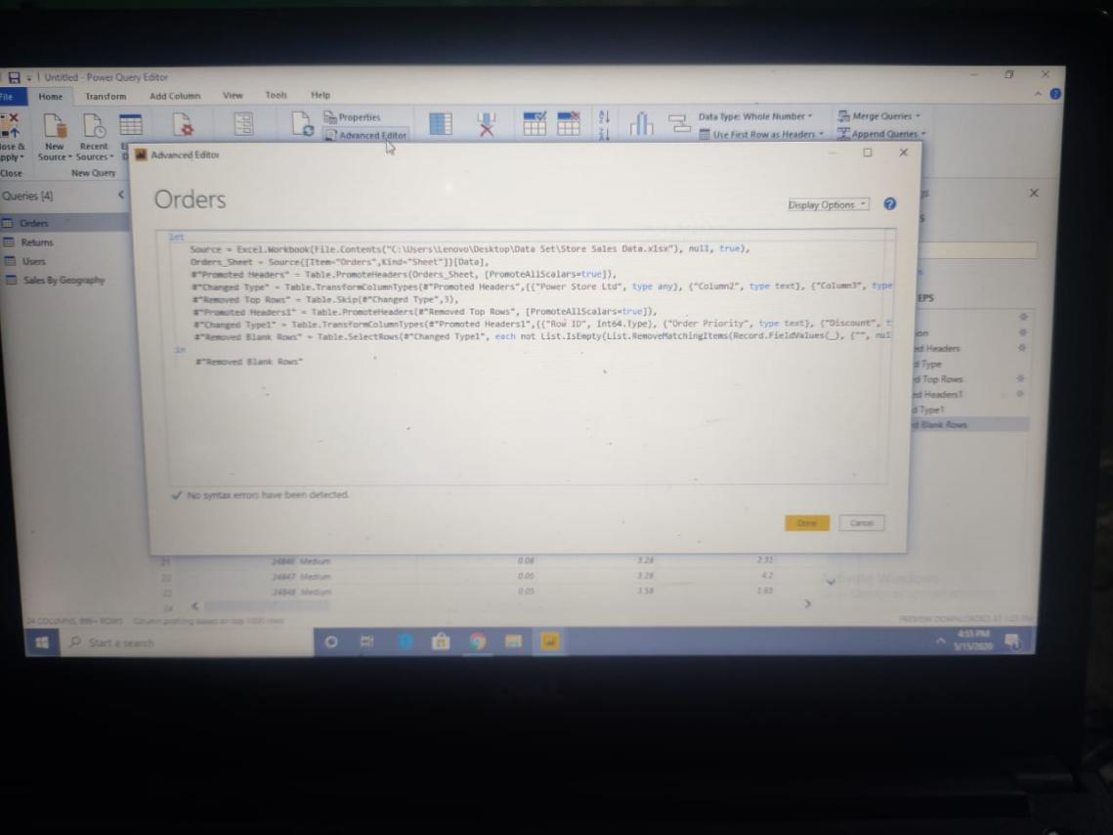

Advance Editor Screenshot

• Prepare a document with details of the following along with their price − Power BI Desktop
− Power BI Pro
− Power BI Premium

Power BI
Microsoft Power BI is a cloud-based business intelligence and analytics service that provides a full overview of your most critical data. Connecting to all of your data sources, Power BI simplifies data evaluation and sharing with scalable dashboards, interactive reports, embedded visuals and more. The huge variety of connectors that are available to be able to just pull in data from literally every data source, the parallel refreshes of the data sources, the extremely powerful ETL tools within the product which comes with its own programming language (M) and finally the expression language DAX, which is a very powerful and innovative way of working with tabular data.

Presently there are three types of power BI available for users:
1: Power BI desktop
2:Power BI pro
3:Power BI premium

Power bi desktop

Power BI Desktop is the free version of Power BI.If you need to consolidate your data sources, create your own reports and conduct your own analysis or test it’s capabilities, it’s the perfect version to start with for all skill levels it's one of the best business analytics tools to use.

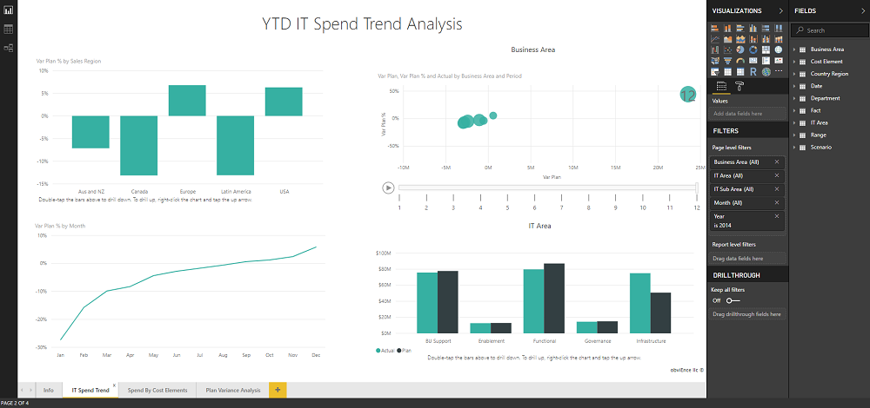

Fig 1:An example of the Power BI Desktop report canvas, viewing an IT spend dashboard.

Feature included in power bi desktop:
- You can connect and import data from over 70 cloud-based and on-premises sources
- The same rich visualisations and filters from Power BI Pro
- Auto-detect that finds and creates data relationships between tables and formats
- Export your reports to CSV, Microsoft Excel, Microsoft PowerPoint and PDF
- Python support
- Save, upload and publish your reports to the Web and the full Power BI service
- Storage limit of 10 GB per user
Limitation in power bi desktop:
- Can’t share created reports with non-Power BI Pro users
- No App Workspaces
- No API embedding
- No email subscriptions
- No peer-to-peer-sharing
- No support to analyse in Excel within Power BI Desktop

Pricing of power BI Desktop: FREE for users.

Power BI Pro
Power BI Pro is the full version of Power BI, complete with the ability to use Power BI for both building dashboards and reports and unlimited viewing, sharing and consumption of your created reports (and reports shared by others) - the latter not possible with Power BI Desktop.
A breakdown of Power BI Pro’s differences against Power BI Desktop:
- Ability to embed Power BI visuals into apps (PowerApps, SharePoint, Teams, etc)
- Native integration with other Microsoft solutions (Azure Data Services)
- Share datasets, dashboards and reports with other Power BI Pro users
- Can create App Workspaces and peer-to-peer sharing
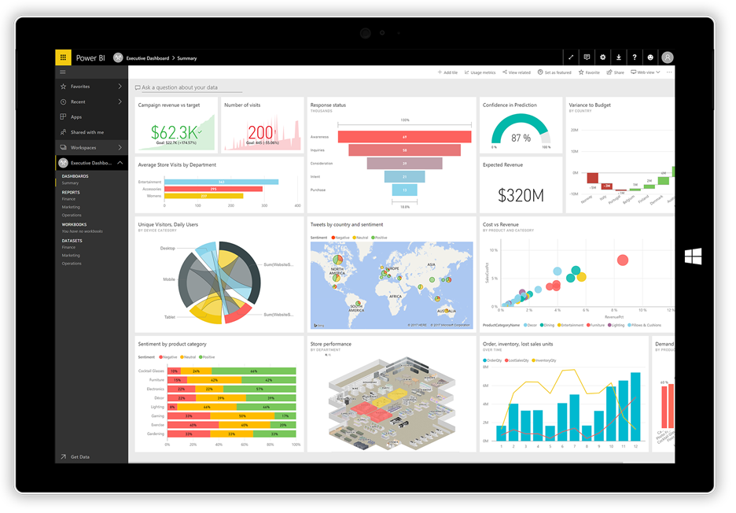
Fig 2:Image of power bi pro user interface

Power BI Pro is licensed by individual user.

Pricing of power BI pro: costs $9.99 per user per month.

Power BI Premium

Power BI Premium is the most expensive tier of Power BI currently available and very distinct from the other two versions available on the market.On top of the features and functionality standard to all versions of the service, users of Power BI Premium get:
- Increased data capacity limits and maximum performance
- Access to one API surface
- Ability to embed Power BI visuals into apps (PowerApps, SharePoint, Teams, etc)
- Larger storage sizes for extended deployments
- Geo distribution, higher refresh rates, isolation, pin to memory, read-only replicas
- Power BI Report Server
Power BI Premium differs from the free version and Power BI pro in its licensing model, which only suits a specific size and type of organisation and business scenario.One can purchase Premium in a range of capacity sizes that offer different numbers of memory and virtual cores that can scale as your data analysis requirements change.
With Power BI Premium, you are licensing capacity for your datasets, dashboards and reports, not just licensing all users of that content. In other words, you’re not buying individual licenses, you’re buying them in bulk to allow a large number of your users to use Power BI to view reports. All of your content is stored in Premium and can then be viewed by as many users in your organisation as you want, without additional per-user costs.

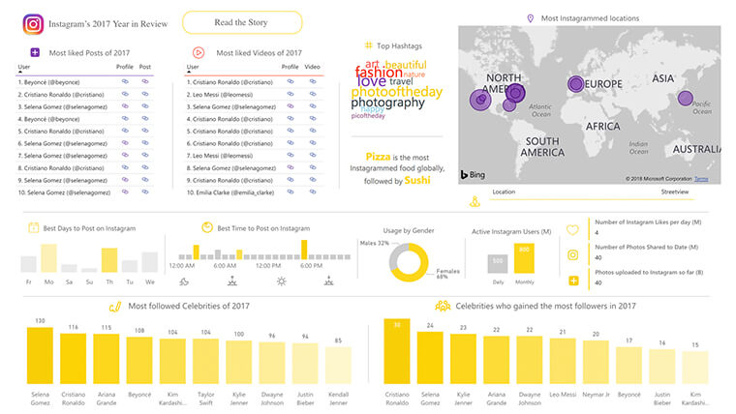
Fig 3: power BI premium
Pricing of power BI Premium:$4,995 a month

